AI DRIVEN CHRONIC PAIN MANAGEMENT
SYSTEM

A Project Report Submitted
In Partial Fulfilment of the
Requirement for the Degree of

Master of Computer Applications

Ayush Rawat 2400520140020
Mohammad Mujtaba 2400520140040
Shivam Kumar Gupta 2400520140062

Under the guidance of
Dr. Upendra Kumar
Ms. Varsha Sharma


Department of Computer Science and Engineering

INSTITUTE OF ENGINEERING AND TECHNOLOGY
Dr. A.P.J. Abdul Kalam Technical University, Uttar Pradesh
Session 2025-26
DECLARATION

We declare that this project submission is entirely our own work and, to the best of our knowledge and belief, it does not contain any previously published or written material by another person, nor does it substantially overlap with any work that has been accepted for the award of a degree at this university or any other institute of higher learning. We have provided appropriate acknowledgements in the text for any material that has been used or referred to.
Furthermore, we confirm that this project report has not been submitted to any other institute in fulfilment of the requirements for any other degree.

Ayush Rawat 2400520140020

Mohammad Mujtaba 2400520140040

Shivam Kumar Gupta 2400520140062

CERTIFICATE

We hereby certify that the project report titled “AI-Driven Chronic Pain Management System” submitted by Ayush Rawat, Mohammad Mujtaba, Shivam Kumar Gupta in partial fulfilment for the award of the degree of Master of Computer Applications, represents their original work under our supervision and guidance at the Department of Computer Science Engineering, Institute of Engineering Technology Lucknow.
We also confirm that to the best of our knowledge, this work has not been submitted anywhere else for the award of any other degree.

(Dr. Upendra Kumar)
Department of Computer Science and Engineering
Institute of Engineering and Technology, Lucknow

(Ms. Varsha Sharma)
Department of Computer Science and Engineering
Institute of Engineering and Technology, Lucknow

ACKNOWLEDGEMENT

We would like to express our sincere gratitude to all those who have supported and guided us during the course of our project. We appreciate the assistance and blessings we have received, which have contributed to the successful completion of this project.
Firstly, we would like to extend our sincere thanks to the Head of the Department, Prof. Girish Chandra, for providing constant encouragement and for fostering an environment that promotes learning, innovation, and research.
Secondly, we are thankful to our supervisor and Co-Project Coordinator, Dr. Upendra Kumar, for his continuous support and guidance throughout our MCA project. His expertise and patience have been invaluable to us and have played a vital role in the accomplishment of this thesis.
Additionally, we would like to express our gratitude to our co-supervisor, Ms. Varsha Sharma, for her invaluable supervision and support during our MCA project. We would also like to express our deep gratitude to our Project Coordinator, Prof. M H Khan, for his consistent support, timely direction, and valuable feedback throughout the course of this project.
We would further like to acknowledge the members of the Project Evaluation Committee for their participation in our thesis review. We are grateful for their valuable feedback and suggestions, which have greatly contributed to the development and writing of this thesis.
Lastly, we would like to extend our deep appreciation to our friends and family for their unwavering love and support throughout this journey. Their encouragement and motivation have been instrumental in our ability to complete this project.

Ayush Rawat 2400520140020
Mohammad Mujtaba 2400520140040
Shivam Kumar Gupta 2400520140062

ABSTRACT

Chronic pain is a long-term health condition that affects millions of people around the world, often interfering with their daily activities, emotional well-being, and overall quality of life. Traditionally, pain is assessed through self-reporting methods, where patients describe their pain level to healthcare professionals. While this approach is widely used, it can be subjective and may not always provide accurate results. It is also difficult to use for individuals who are unable to communicate their pain effectively, such as young children, elderly patients with cognitive impairments, unconscious patients, or people with communication disorders.
To overcome these challenges, this project proposes an AI-Driven Chronic Pain Management System that can automatically estimate pain levels using physiological signals collected from wearable devices. Instead of relying solely on a patient's verbal feedback, the system analyzes real-time body responses that are often associated with pain.
The proposed system uses data gathered from a smartwatch-like wearable device equipped with multiple sensors. These sensors measure physiological parameters such as Blood Volume Pulse (BVP), Electrodermal Activity (EDA), skin temperature, and body movement through accelerometer readings along the X, Y, and Z axes. The collected data is first preprocessed and transformed into meaningful features that can be used for machine learning analysis.
Several machine learning algorithms, including Random Forest, Support Vector Machine (SVM), Gradient Boosting, and other classification techniques, are employed to predict pain intensity levels on a scale of 1 to 8. The performance of these models is compared based on factors such as classification accuracy, feature importance, and overall predictive capability, with the goal of identifying the most effective model for pain estimation.
The main objective of this project is to enable continuous and objective pain monitoring while reducing dependence on subjective pain assessments. By providing real-time insights into a patient's pain condition, the system can assist healthcare professionals in making more informed decisions and delivering timely interventions.

LIST OF FIGURES

1.1 End to End Healthcare AI Ecosystem Flowchart……………………………………...….....2
3.1 Overall Modular System Architecture Block Diagram……........................……...…….…...9
4.1 Relational Database Schema ER Block……………………..………………………….…..16
4.2 DFD Level 0 Data Flow Process Diagram…………………….…………………………...17
4.3 DFD Level 1 Data Flow Process Diagram…………………….…………………………...18
4.4 Use Case Diagram…………………….…………………………………….……………...18
5.1 Validation Confusion Matrix……………….………………...…………………………….20
5.2 Validation Accuracy Performance Comparison Matrix…...………...……………………..20
5.3 User Interface……………………………………………………………………………….21
5.4 User Dashboard…………………………………………………………………………….21
A.1: Plagiarism Analysis Report…………………………………..…………………………. .26
A.2: AI Content Detection Report………………………………..…………….………………27

LIST OF TABLES

2.1 Structural Comparison of Existing and Proposed System……………………..………….…..5
2.2 Physiological Measurement………………………………...…….......…...............................6
3.1 Dataset Description………………………….……………...…….......….............................10
4.1 Comparative Machine Learning Model Performance Sum…………...….............................18

CONTENTS

Declaration………........................................................................................................................i Certificate.....................................................................................................................................iiAcknowledgement.......................................................................................................................iii Abstract…....................................................................................................................................iv List of Figures……......................................................................................................................v
List of Tables .............................................................................................................................vi

CHAPTER 1 INTRODUCTION……………………………………………………..……...1-4
1.1 Background and Motivation…………………………………………….………...1
1.2 Healthcare Challenges and Subjective Biases………………………….…………2
1.3 Needs for Objective AI-Based Assessment…………………………….…………2
1.4 Problem Statement……………….…………………………………….………….3
1.5 Role of Wearable Sensors……………………….…………………….…………..4
1.6 Role of Machine Learning…………………………………………….…………..4
1.7 Objectives of the SysteM……………………………………………….…………4

CHAPTER 2 LITERATURE REVIEW………………………………………………….....5-9
2.1 Physiological Dynamics of Pain…………………….………………..…………...5
2.2 Traditional Pain Assessment Methods………………………………………….....5
2.3 Physiological Indicators of Pain…………………………………………………..6
2.4 Wearable Technologies in Healthcare Monitoring………………………………..6
2.5 Use of Machine Learning in Biomedical Signal Analysis……………….………..7
2.6 Research Gap………………………….………………………………….……….7
2.7 Summary……………..……………………………………………………………7

CHAPTER 3 METHODOLOGY……………..……………………………………………8-14
3.1 Overview of the System…………………………………..……………………....8
3.2 System Architecture……………………………..………………………………..8
3.3 Advanced Feature Engineering and Signal Integration…………………...………9
3.4 Dataset Description………………………………………..……………………..10
3.5 Data Preprocessing………………………………………………………..……...11
3.6 Advanced Feature Engineering and Signal Integration……………………….…11
3.7 Mathematical Formulations of Machine Learning Classifiers…………..………11
3.7 Mathematical Validation Formulas………………………..……………………..13
3.8 System Modeling ………………………………..……………….………………14

CHAPTER 4 IMPLEMENTATION DETAILS………………..………………………..15-18
4.1 Modern Technology Stack Selection………………………..…………………..15
4.2 Localized Development Environment……………………….………………….15
4.3 Database Schemas and Object-Relational Models...…………………………....15
4.4 Flask Backend API Implementation…………….………………………………16
4.5 React SPA Dashboard Frontend Implementation……………….………………17
4.6 Data Preprocessing and Validation Pipeline…………………….………………17
4.7 Data Flow Diagrams (DFD Levels)……………………………………………...17
3.8 Use Case Modelling…………………………………………….......................…18
CHAPTER 5 SYSTEM WALKTHROUGH AND RESULTS…………….……………19-21
5.1 Experimental Protocols and Train-Test Splitting………………..………………19
5.2 Performance Metrics and Benchmark Summaries………….…………………...19
5.3 Comparative Model Validation Matrix Analysis………….………………….…19
5.4 React Web Client UI and Prediction Walkthrough……….……………………..20

CHAPTER 6 LIMITATIONS AND FUTURE WORK……………………………..…..22-23
6.1 Project Objectives Accomplishment Assessment…..……………………………22
6.2 Key Core Technical and Clinical Strengths…..…………………………………22
6.3 Current Technical Limitations and Vulnerabilities……..……………………….22
6.4 Future Ingestion Roadmap and IoT BLE Frameworks………….………………22

CHAPTER 7 CONCLUSION………………………………………………………………...24

REFERENCES………………………………………………………………………………..25

APPENDICES……………………………………………………………………………..26-27
Appendix A: Plagiarism Statement………………………..…………………………...26

ANNEXURES…………………………………………………………………...…..……..28-33
Annexure 1: Backend Feature Engineering and Inference Engine……………….….…28
Annexure 2: Backend Relational Database Schema Models…….……………….….…30
Annexure 3: Frontend React CSV File Processing and API Ingestion Logic…….….…32

CHAPTER 1
INTRODUCTION

Chronic pain is a long-term health condition which lasts longer than the usual time frame for healing, typically beyond six weeks. It may affect a person's physical, emotional and quality of life. Chronic Pain is one of the most frequent health issues globally and can decrease productivity, impact sleep, limit functional activities, and contribute to anxiety and depression. While acute pain is typically short lasting and associated with an injury or illness, the chronic pain is complex and more challenging to assess. Its intensity and symptoms may be vastly different among different individuals and may not always reflect clinical findings. Hence, it is critical to assess and continuously monitor patients' chronic pain to aid in treatment, pain management and patient outcome.

  - Background and Motivation
Chronic pain is one of the most widespread and challenging health conditions faced by people today. Unlike acute pain, which acts as the body's natural warning signal in response to injury or tissue damage, chronic pain continues long after the original cause has healed. It is generally defined as pain that persists for more than three to six months, either continuously or intermittently. Millions of people around the world live with chronic pain, and its effects extend far beyond physical discomfort. It can negatively impact mental health, daily activities, work performance, and overall quality of life. In addition to the personal burden, chronic pain places a significant strain on healthcare systems and economies through ongoing medical treatments, rehabilitation costs, medication expenses, and reduced workplace productivity.
The motivation for this project arises from a major challenge in pain management: pain is highly subjective and differs from person to person. The way the human nervous system processes pain is influenced by several factors, including genetics, emotions, previous experiences, and environmental conditions. As a result, there is currently no objective device that can directly measure pain in the same way that a thermometer measures temperature or a blood pressure monitor measures blood pressure. Healthcare professionals must rely largely on patient self-reports and visual pain scales, which can often be inconsistent and prone to bias. To address this limitation, this project focuses on using physiological signals collected from wearable sensors and applying advanced machine learning techniques to estimate pain levels objectively. By identifying reliable physiological markers of pain, the proposed system aims to create a more consistent and unbiased approach to pain assessment. Such a solution could improve clinical decision-making, support personalized treatment strategies, reduce dependence on opioid-based medications, and provide valuable assistance in monitoring patients who are unable to communicate their pain effectively.

1.2 Healthcare Challenges and Subjective Biases
There are a number of problems with the traditional health care system in the assessment and management of pain. Most commonly, self-reporting scales are used, including the Visual Analog scale (VAS) and Numeric Rating scale (NRS), which rely entirely on patients' own description and rating of their pain experiences. However, they are subjective as a number of factors, including memory recall, emotional state, stress level and personal or cultural perceptions of pain, may affect them. This means that the pain level reported may not accurately reflect the patient's pain.
These restrictions are even more severe when a population is not able to express itself. Children under a certain age, very old patients with dementia, patients with language or other communication problems, and patients recovering from surgery and/or anesthesia may not be able to make accurate self-assessments. In such situations, health care providers may have little information to use when deciding on treatment. Further, it can be challenging for clinicians to differentiate from other responses of physical and emotional distress from actual pain. This uncertainty can result in poor pain management, leaving the patient unnecessarily suffering or in over consumption of pain relievers that can cause undesirable effects and dependence on pain medication.

1.3 Needs for Objective AI-Based Assessment
Recognizing the drawbacks of subjective methods of assessment, contemporary health care has come to embrace the use of objective physiological indicators as a means of assessing pain. The Sympathetic Nervous System (SNS) is activated by pain, and it stimulates the body's "fight-or-flight" response. The physiological response causes changes to the body that can be measured with wearable biosensors. These signs are measured through electrodermal activity (EDA), blood volume pulse (BVP), heart rate variations, skin temperature variations and body movement patterns using accelerometer sensors.
This is a complex physiological data that's processed and interpreted with great help from artificial intelligence and machine learning. The signals received are typically high-frequency and subject to various external factors, so advanced machine learning algorithms are employed to isolate significant patterns from the noise and other factors related to motion. These models can predict the intensity of pain experiences in real time with greater objectivity and consistency, as compared with traditional self-reporting assessments, by examining correlations between different physiological measures.

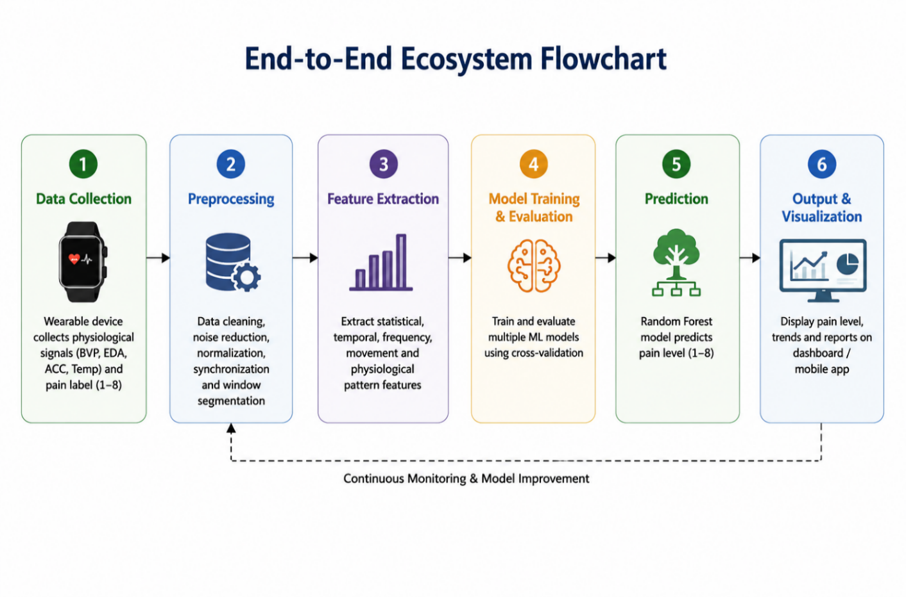Figure 1.1: End-to-End Healthcare AI Ecosystem Flowchart

1.4 Problem Statement
While sensor-based pain assessment systems have great potential, there are still a number of issues that need to be addressed to enable them to be widely used in clinical patient care environments. The main challenge is the quality of physiological data that can be collected through wearable devices. Signals obtained from wrist-worn sensors are often affected by noise and external disturbances. Sudden movements, changes in temperature, changes in skin contact, and emotional stress (that are not pain related) are just a few of the factors that can impact sensor readings. This makes it hard to differentiate the physiological response to pain from other physical and psychological responses.
The area of difference between research machine learning models and actual clinical use is also a significant hurdle. The majority of previous research on AI-assisted pain assessment is performed in a controlled setting, with pre-processed datasets and machine learning experiments performed offline. Although these studies achieve good results, they do not necessarily have the necessary infrastructure for a clinical setting in health care. The majority of healthcare professionals are not equipped with the systems that can receive real-time sensor information and automatically predict pain, record all patient history and data, and give them understandable visualizations for clinical decision making.

1.5 Role of Wearable Sensors
Wearable technologies have opened new possibilities for real-time and continuous health monitoring in the past few years. Smart devices like smartwatches and fitness bands can now gather a range of physiological data, which could relate to pain and stress. Such signals are Blood Volume Pulse (BVP), Electrodermal Activity (EDA), Accelerometer X, Y and Z, and Skin Temperature. These physiological parameters tend to change when the body is in pain, stress or emotional and physical state.

1.6 Role of Machine Learning
In parallel to the development of WWT, Artificial Intelligence (AI) and Machine Learning (ML) are powerful tools for the analysis of complex physiological data. These technologies can detect patterns and relationships in biomedical signals that are not easily discerned by using traditional methods of analysis. Machine learning can analyze vast quantities of data from various medical devices to identify patterns and trends that can aid in medical diagnosis, monitoring, and decision-making. Machine learning models can analyze large volumes of data from medical sensors and devices to identify patterns and trends that can help with medical diagnosis, monitoring, and decision-making. Wearable sensing and AI technologies offer a promising way towards the creation of continuous, personal, and scalable automated pain monitoring systems.
In this current work, the AI-Driven Chronic Pain Management System is being developed to estimate pain automatically from physiological signals captured from wearable devices. This proposed system receives signals related to pain from various sensors like blood volume pulse, electrodermal activity, skin temperature and accelerometers. The retrieved information is then pre-processed for noise elimination, inconsistencies and to enhance its quality. Features that are relevant to the problem are added to the cleaned data and the machine learning models are trained to predict pain intensity levels (1-8). Various classification techniques such as Random Forest, Support Vector Machine (SVM), Gradient Boosting were used and evaluated.
1.7 Objectives of the System
The proposed solution is designed to help with continuous remote monitoring and better pain management. It's different to the standard pain assessment that's usually carried out on paper or infrequently seen by a healthcare professional, which can allow for more frequent and up-to-the-minute reporting of a patient's pain level. Reg by Reg monitoring gives medical professionals a more comprehensive understanding of conditions changing over time, so they can intervene sooner and make better decisions on how to treat the patient. It could also be applied to many other health-related fields such as telemedicine, recovery after surgery, physiotherapy, pain caused by menstruation, pain from migraine and care for the elderly.
To sum up, in this project we aim to show that wearable sensing technology and machine learning can be effective, objective, and non-invasive methods for monitoring chronic pain. The system can use information from the sensors of wearable devices to more accurately and consistently estimate pain levels than self-reporting methods. The proposed solution aims to complement the work of healthcare professionals, providing them with an aid to enhance clinical judgment, early intervention, and the objectivity of pain assessment, and consequently the comfort, safety, and quality of care provided to patients.

CHAPTER 2
LITERATURE REVIEW

2.1 Physiological Dynamics of Pain
Pain is a multifaceted experience of the biological system, sensory, affective and cognitive. From a neurophysiological point of view, pain is triggered by the activation of specialized sensory receptors called nociceptors which detect potentially harmful mechanical, thermal or chemical stimuli present in the skin, muscles, joints and internal organs. A once activated receptor starts to send out electrical signals that travel via the fast and sharp pain-sensing myelinated A-delta fibers, and the slower, dull, aching-sensing unmyelinated C fibers. These signals go to the dorsal horn in the spinal cord and then pass through the spinothalamic tract to the thalamus.
Meanwhile, signals of pain trigger certain autonomic centers in the brainstem and hypothalamus which activate the Sympathetic Nervous System (SNS) and inhibit the parasympathetic nervous system.

Table 2.1: Comprehensive Structural Comparison of Existing vs Systems

Feature Attribute | Traditional Diagnostic Systems | AI-Based Proposed System
Primary Diagnostic Basis | Subjective Self-Report (VAS/NRS 0-10) | Objective Autonomic Biomarkers
Data Collection Mode | Intermittent, Manual, Retro-Recall | Continuous, High-Freq 4Hz Real-Time
Vulnerability to Bias | High (Recall, Cognitive, Emotional Bias) | Very Low (Involuntary Sympathetic Response)
Non-Verbal Utility | Completely Ineffective | Highly Effective and Clinically Intuitive
Technological Medium | Paper Forms or Standard Static Forms | React SPA Dashboard & Flask ML Microservices
EHR Integration | Extremely Difficult, Pure Textual Logs | Seamless, PDF Report Generation & SQL Database

2.2 Traditional Pain Assessment Methods
Self-reports of pain have long been used as the standard method for assessing pain in the clinical setting. The most common scales used are Visual Analog Scale (VAS), Numerical Rating Scale (NRS), Wong-Baker Faces Scale and verbal questionnaires. In healthcare applications, they are used extensively due to being simple, cost effective and easy to administer. They come, however, with certain restrictions. Everyone experiences pain in their own way and emotional state, stress, culture and personal pain tolerance all play a role in how people perceive pain. Other patients, such as young children, elderly patients with cognitive deficits and non-verbal patients, may not be able to accurately communicate pain.

2.3 Physiological Indicators of Pain
Long standing pain has been shown to cause measurable change in the autonomic nervous system. There are several studies that have shown a relationship between pain intensity and physiological signals obtained from the skin and cardiovascular system. Some important measures can be:
Table 2.2: Physiological Measurement

Physiological  Measurement | Significance
Blood Volume Pulse (BVP) | Reflects heart rate and vascular changes influenced by pain or stress.
Electrodermal Activity (EDA) | Represents sweat gland activity linked to sympathetic nervous system activation.
Skin Temperature | May decrease or fluctuate due to vasoconstriction during pain episodes.

Several studies underscore the high reliability of these bio-signals as pain level indicators. These indicators have been captured with the help of wearable devices, enabling the collection of indicators continuously and non-invasively in real world settings beyond laboratory environments.

2.4 Wearable Technologies in Healthcare Monitoring
Wearable technology, such as smart watches, fitness trackers and even biomedical smart bands, has transformed how people monitor their health in real-time. Wearable smart devices today can record a variety of physiological readings like heart rate, skin conductance, movement and sleep stages continually. These functions enable wearables to signal early signs of physiological changes and help facilitate proactive health care management. There are several applications of wearable technology today such as cardiac health monitoring, stress and fatigue detection, prediction of seizures, sleep quality assessment and fitness and performance tracking.
Continuous data collection of physiological data without disrupting daily activities is one of the major benefits of the wearable devices. Wireless communication technologies like Bluetooth and Wi-Fi allow sensor data to be communicated seamlessly to the mobile application, cloud platforms or web-based dashboards where they can be stored, analyzed and visualized. This is a continuous, non-invasive data collection feature that can help make wearable technology ideal for chronic pain monitoring applications.
Another benefit of wearable devices is that they allow for the tracking of physiological and behavioral changes in real time that can be linked to pain episodes. Machine learning algorithms can be applied to analyze data from these sensors to detect patterns associated with pain, pain intensity, and predict pain outbreaks. This information can help doctors and other health care providers make timely decision. Wearable tech is also vital to remote patient monitoring, cutting down on frequent visits to healthcare facilities, and making patients' lives easier and available to medical care. Moreover, the ability to follow patients over time with ongoing data collection can be valuable in understanding patterns of pain over time, designing individual treatment programs, and finally enhancing the quality of care and health outcomes for patients.

2.5 Use of Machine Learning in Biomedical Signal Analysis
The capacity of detecting nonlinear patterns in complex biomedical data has made machine learning a major success in analyzing such data. Random Forest, Support Vector Machine (SVM), Decision Trees, Gradient Boosting and Neural Networks are some of the several ML models used in the following applications:
- The data sets for the ECG signal and EEG signal classification.
- Determination of facial emotions on the basis of physiology.
- Posture recognition, physical activity.
The models can learn from the features such as signal frequency, amplitude changes and temporal patterns. In pain classification, ML models are solely trained by the multi-sensor wearable data for the purpose of mapping the physiological pattern to the intensity levels of pain. Successful adoption of machine learning could enable automated, consistent and objective pain-level prediction.

2.6 Research Gap
Although AI and medical technologies have come a long way, automated pain monitoring systems remain in their infancy. Existing approaches show some major disadvantages as per current research. Most of the clinical pain assessment still relies on the subjective patient report, not on objective physiological measures. Furthermore, few systems can estimate pain in real-time in normal environments away from the hospital or research lab. Another difficulty is the fact that many of the previous studies utilize one physiological sensor, while chronic pain is a multiple-signal issue which could require analysis of several physiological signals collected concurrently.
These constraints underscore the necessity to have a more comprehensive and practical solution on pain monitoring. So, a solution that allows for the continuous monitoring of physiological data from the wearable sensors, analyses the data with machine learning methods to estimate pain level in real-time and allows for easy access to the results through a mobile application or Web-based Graphical User Interface would be very much needed.

2.7 Summary
There is a trend in the literature from subjective pain assessment to objective, technology-driven methods. Continuous monitoring with wearable device and powerful machine learning tools to analyze physiological changes related to pain. But in reality, there is a lack of systems available for automated pain monitoring that are practical, real-time and accessible.

CHAPTER 3
METHODOLOGY

The chapter provides an elucidation for the entire methodology approach to be used in developing the AI-Driven Chronic Pain Management System. The methodology consists of data collection, multi-commodity physiological signals preprocessing, feature extraction, machine learning model development, and system design for deployment. A detailed description of each component is given to show the implementation of the system.

3.1 Overview of the System
The proposed system is based on the principle of collecting physiological signals from wearable devices, processing the collected data by using machine learning methods and predicting the pain intensity within the range of 1-8 numerically. The overall methodology consists of a number of significant steps. The initial phase is gathering the physiologic data from wearable sensors, such as data involving cardiovascular activity, skin response, body movement and temperature. This collected data is then preprocessed and noise is removed, missing data is compensated for, and the overall data quality is enhanced.
After this, feature extraction and feature engineering are used to discover important patterns and features in the sensor data. These features are then fed to train and test several machine learning algorithms to classify the pain level. The different algorithms are tested to obtain the best model for accurate pain prediction. Lastly, the chosen model is incorporated into a web-based or mobile app that allows for live estimation and monitoring of pain. The main goal is to create an intelligent, easy-to-use and reliable system that can provide pain level classification continuously and assist in their pain management.

3.2 System Architecture
The system is designed to have the following layers of architecture:
1. Wearable Sensor Layer
This layer is a smartwatch-type device with embedded sensors that are able to collect physiological data including:
- Blood Volume Pulse (BVP)
- Electrodermal Activity (EDA)
- Skin Temperature
Every sensor produces data at set sample rates, allowing the accurate and continuous measurement of physiological variations with time. The signals collected form a time-series of data, with each signal representing a measurement and a corresponding time stamp. This structure allows the system to interpret changes, trends and patterns in the user's physiological condition.

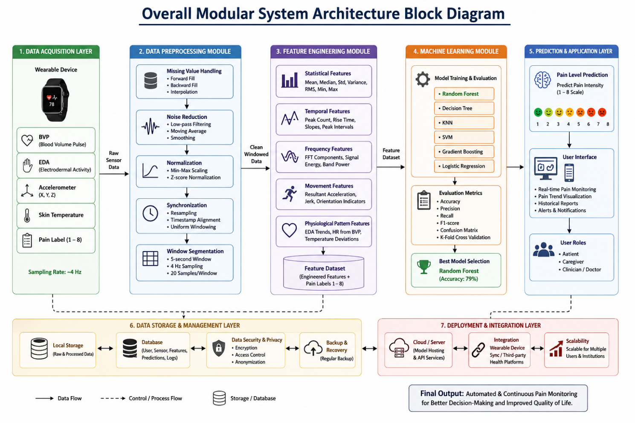
Figure 3.1: Overall Modular System Architecture Block Diagram

2. Data Processing Layer
This layer is related to the following:
- Noise removal
- Signal normalization

3.3 Advanced Feature Engineering and Signal Integration
Three extra cross-sensor features were generated and added to the feature set for better predictive performance of the machine learning models. These features have been developed to reflect clinically relevant physiological relationships that could be related to pain and stress responses

1. 3-Axis Accelerometer Magnitude (acc_magnitude):
Human movement takes place in three dimensions within the body; in the X, Y, and Z axes of the accelerometer. The intensity of the movement was determined on each of the two axes, but also a total body movement was calculated using the Euclidean norm:
acc_magnitude = \sqrt{acc_x^2 + acc_y^2 + acc_z^2}
This feature allows for the capture of overall movement activity of the patient and may be useful for identifying movement patterns that can be associated with patient pain or discomfort.

2. Stress Index (stress_index):
EDA and Heart Rate (HR) tend to fluctuate at the same time when a person is in pain or experiencing physiological stress. To account for the overall effect of these responses, a feature called the Stresses Index was developed, by taking the product of EDA and HR:
This is eda \times hr = stress_index.
This feature is useful to account for the interaction between cardiovascular activity and skin conductance thus providing a more complete picture of autonomic nervous system activation.
3. Skin Temperature Delta (temp_delta):
A vasoconstriction may be responsible for the temporary changes in skin temperature that may occur due to pain-related sympathetic activation. A Temperature Delta feature was computed by subtracting the average baseline temperature from the current temperature, to measure these fluctuations separately from an individual's baseline temperature:
temp_delta = |temp - temp_mean|
This feature identifies temperature differences that could correspond to a physiological stress and/or pain response.

3. Machine Learning Layer
This consists of:
- Splitting the dataset
- Evaluating model performance

4. Application Layer
A web dashboard is used to display final predictions. This can be used to show the trends in pain level over time, and lets health care professionals or users track changes.

3.4 Dataset Description
The data included in this dataset is collected from a wearable device monitoring sensor data for the project. From the information available in the sample of data:

Table 3.1- Dataset Description

Feature | Meaning
BVP | Blood Volume Pulse (related to heart rate and HRV)
EDA | Skin conductance (stress/pain indicator)
X, Y, Z | Accelerometer axes (movement intensity & direction)
Temperature | Skin temperature in degrees Celsius

The dataset contains time-series readings sampled at approximately 4Hz, meaning four sensors readings per second.

3.5 Data Preprocessing
In general, biological data collected via the non-invasive biosensors will be prone to sensor drift, noise, and gaps in data. The data preprocessing pipeline performs three consecutive cleaning operation:

Step 1: Missing Value Imputation, the dataset can contain temporal disconnections and/or skin contact resistance shifts, which will lead to missing entries. As machine learning classifiers require dense input matrices, it fills the dataframe with missing values by adding forward filled values for shorter missing time blocks and linear interpolation for longer missing blocks.
Step 2: High-Frequency Smoothing: Raw EDA and BVP signals have high frequency noise due to micro-movements. Smoothing raw signals: a low pass Butter worth filter with a cutoff frequency of 0.5Hz is applied.
Step 3: Standardization & Scaling: There are variations in the scale of physiological parameters (e.g., Temperature is around 34C, while BVP can rise up to 100).

3.6 Advanced Feature Engineering and Signal Integration
Three advanced cross-sensor interactive features were designed and appended to the raw feature vector matrix to gain the maximum predictive accuracy of the classifiers:
In physical space, a patient's motion is measured in X, Y and Z coordinates, which is referred to as the 3-Axis Accelerometer Magnitude (acc_magnitude). The magnitude of the accelerometer is computed according to a formula developed for the Euclidean norm which is adapted to use for the kinetic energy of the patient:
acc_magnitude = sqrt(acc_x^2 + acc_y^2 + acc_z^2)
Stress Index (stress_index): An increase in physiological stress and a rise in nociceptive response result in a simultaneous rise of both skin conductance (EDA) and cardiac pacing (HR). A non-linear, multi-modal synergy called Stress Index was developed to capture this autonomic synergy:
stress_index = eda * hr
A localized drop in skin temp (Skin_Temperature_Delta = temp_delta) is the result of vasoconstriction. A Temperature Delta feature was designed, and is computed as the absolute deviation from the running mean baseline, independently of the patient's baseline temperature:
temp_delta = |temp - temp_mean|

3.7 Mathematical Formulations of Machine Learning Classifiers
In this section, mathematical formulations of machine learning classifiers are discussed.The mathematical formulation for machine learning classifiers is discussed in this section.
To identify the most accurate and efficient machine learning classifier, the project thoroughly analyzed and compared six classifiers.

3.7.1 Random Forest (RF) Classifier
Random Forest model is a strong ensemble machine learning model, which during training creates multiple decision trees. The strategy of using a different subset of the training data for each tree, called bagging, is used to improve the performance of each tree in order to reduce the risk of overfitting. Also, at each decision point, a random subset of features is assessed for use, so that the trees are more diverse and the model learns more about prediction of data not included in the training set. The output from the model is the class predicted by the most trees in the voting done by the majority.
For this project, a Random Forest (RF) classifier was set with 100 decision trees and was used the Gini impurity criterion to measure the goodness of the split. The ensemble implemented the model, allowing it to successfully model complex and non-linear relationships between the physiological features derived from wearable sensor information. Consequently, it was found to have highest validation accuracy of 78.67% as compared to all other evaluated machine learning models and therefore most effective in classification of pain levels in the proposed system.

3.7.2 K-Nearest Neighbors (KNN)
The K-Nearest Neighbors (KNN) algorithm belongs to instance-based machine learning and is a non-parametric method which classifies the input sample as the output sample of the neighbor (most similar sample) in the training data set. In contrast to creating a predictive model during training, KNN models the training data, but rather than building a model, it simply stores the data and predicts by finding the ‘K’ closest neighbors to the test case in the feature space during test. This neighboring instance then votes for the class label of the new data point, and the class label of new data item is assigned according to the most common vote.
The value of K used in this project was 5 and the similarity between data points was calculated with the Euclidean distance measure. The KNN model showed good classification with 72.44% accuracy on validation set. It is useful for many prediction problems because it can be used to classify the data according to the local patterns. But, while training, the computational cost of KNN increases with the number of training instances, due to the computation of the distance between the new instance and each training instance when prediction is done. This can decrease the speed of inference, limiting KNN's application to large datasets and/or high-frequency real-time deployments in web-based pain monitoring systems.

3.7.3 Support Vector Machine (SVM)
Supervised Machine Learning Algorithm Support Vector Machine (SVM) is used to find the best separating hyperplane for different classes in the feature space. The main goal of SVM is to maximize the separation between the classes, which improves the generalization on unseen data. In this work, physiological signals are observed to have non-linear and complex relationships between them, thus, the SVM model used a Radial Basis Function (RBF) kernel which maps the input features to a higher dimensional space to enable the separation of classes.
In this implementation the model is setup with the regularization parameter C = 1.0 and gamma='scale'. These parameters are used to balance the classification accuracy and complexity of the model, and to customize the kernel function to the data distribution. The validation accuracy for SVM model is 57.34%. SVM is often successful for classification problems, but in this project the classification was hampered because of noisy data from physiological sensors and the large separation of classes of intermediate pain levels. Such effects were a challenge for the model to decide clear boundaries and led to poor classification performance in comparison to other algorithms tested.

3.7.4 Decision Tree Classifier
Decision Tree algorithm is a supervised learning algorithm which builds a decision tree in the form of a hierarchy of decision trees using the values of the features. The algorithm works by choosing the feature and threshold with the greatest information gain at each decision step, thus making decisions based on a sequence of decision rules to classify data. The main benefits of Decision Trees are the "ease with which the decisions in a decision tree can be presented to a human user (this can be done visually),"; But an individual Decision Tree is prone to over-fitting, particularly if it memorizes the patterns it sees in the training data, rather than learning trends. It is also sensitive to small variations in the dataset that can result in different structures in the tree and in its predictions. In order to minimize the risk of overfitting, the model used in this project was set to stop growing at 15 levels, which would keep the complexity of the model down and limit the amount of training data that it memorized.
The Decision Tree classifier's validation accuracy was 69.47%. This performance shows it can identify the relevant relationships between the physiological data, but it was still worse than the Random Forest model. The result shows that ensemble methods, which usually establish a better accuracy, stability and generalization than a single decision tree-based model, are more advantageous.

3.7.5 Gradient Boosting Classifier
Gradient Boosting is an ensemble machine learning method that sequentially builds multiple decision trees. Random Forest constructs trees independently while Gradient Boosting constructs each new tree to correct the errors or residuals made by the previous trees. Over time, as the model repeatedly accesses misclassified samples, it progressively gets better at predicting correct classifications, and can begin to learn intricate structures of data that is already organized. Through repeated visits to misclassified samples, one by one, the model gradually improves its predictive ability, and can eventually identify complex structure in structured data.
However, Gradient Boosting was observed to be very sensitive to the high frequency noise and motion related artifacts seen in the Physiological sensor data used in this project and, therefore, not suited for application to this data type. As the model started fitting more complex patterns, it increasingly started to overfit the data and thus was not able to generalize well to unseen data. The Gradient Boosting classifier is one of the lower performing classifiers in terms of validation accuracy of 51.37%. The strength of this result lies in the difficulties of using highly sensitive boosting methods on noisy physiological data without large amounts of noise reduction and optimization procedures.

3.7.6 Logistic Regression Baseline
Logistic Regression is the basic linear model that takes a weighted sum of the input features and uses the SoftMax function to get the probability for a multiclass use case. One of the assumptions of Logistic Regression is linear separability across classes, while the non-linear and interactive nature of human physiological stress is quite complex. It thus had the poorest accuracy rate of 43.68% when validated.

3.7 Mathematical Validation Formulas
Four well known clinical parameters were also calculated: Accuracy, Precision, Recall, and F1-Score to fully understand how the classification models do their job. These measures are mathematically defined as:
- Accuracy = (TP + TN) / (TP + TN + FP + FN)
- Precision = TP / (TP + FP)
- Recall (Sensitivity) = TP / (TP + FN)
- F1-Score = 2 * (Precision * Recall) / (Precision + Recall)

3.8 System Modeling
Data processing lifecycle is divided into various levels of the system. DFD Level 0 (Context Diagram) represents a single process system whereby a Patient or Clinician uploads a raw CSV file and receives a pain assessment report – the system handles the secure relational queries with the database system. DFD Level 1 presents a detailed description of the Backend Modules and describes the exact order of data flow:
- The User upload a raw CSV log via the User Web Client.
- The request's JWT token is validated by Flask Backend Auth Service.
- CSV schema validation and columns to Pandas Data Frame by the File Processor.
- The Preprocessing Module normalizes and soothes the signals with StandardAero transformations.
- The Feature Engineer creates a few additional columns: ‘acc_magnitude', ‘stress index', and ‘temp_delta'.
- The load the Random Forest model and predict multiclass pain scores in the following step called the Inference Module.
CHAPTER 4
IMPLEMENTATION DETAILS

4.1 Modern Technology Stack Selection
A robust and updated technology stack was chosen to work with the proposed pain monitoring system to ensure that it would be scalable, performant, easy to use, and secure to operate.
React.js was chosen for developing the frontend interface due to its component-based architecture and efficient rendering capabilities. TypeScript offers static type checking to increase code reliability and decrease runtime mistakes. Vite was chosen as the build system due to its rapid development environment, lightning-fast compilation time, and ability to handle instant Hot Module Replacement (HMR) for fast application development.
Its utility-first approach to styling was used to design responsive and customizable user interfaces with Tailwind CSS. This was achieved by using Tailwind CSS which is known for its utility-first styling approach. Shaden UI was integrated to offer contemporary, accessible, and professionally designed interface elements including cards, tables, alerts, dialogs, forms and more. These technologies coalesce to help develop a clean, easy to use clinical dashboard for pain monitoring and data visualization.
RESTful APIs were developed with the Flask backend framework. Flask was chosen as the framework for the development of RESTful APIs. It is also lightweight and modular, allowing for easy integration with a variety of Python data processing and machine learning libraries. Flask makes making user requests, processing data to be used in models, inferring the model, and communicating between frontend and backend systems very efficient.
MySQL is a relational database management system used for managing and storing structured data. It helps store user data, authentication logs, uploaded datasets, pain assessments, and other system-related information, ensuring reliability, consistency, and efficient retrieval of data.
The machine learning models used for classification of the level of pain were developed and trained using scikit-learn and evaluated. For fast loading of the trained models and real-time prediction for the deployed application, Jabil was used for the efficient serialization and deserialization of the machine learning models and the preprocessing components.

4.2 Localized Development Environment
A localized workspace setup was used with version control using Git. The backend environment uses a virtual environment (venv) with Python 3.10, to keep the library dependencies separate from other environments. A strong dependency management is handled with the 'requirements.txt' file. The front-end stack is based on Node.js v20 with npm as a package manager.

4.3 Database Schemas and Object-Relational Models
The MySQL database schema is built around two main tables: the `users` table and the `reports` table, both of which deal with the data of users and with the created assessment records. The `users` table holds user information, including credentials, profile data and authentication information needed for secure access to the system. The `reports` table stores the results of predictions, the summary of the predictions assessment, the date of the prediction, and other data related to the prediction being processed by the application. These tables are also mapped to Python classes with SQL Alchemy’s Object-Relational Mapping (ORM), and the goal is to make these tables as easy to interact with as possible. This ORM approach enables developers to write Python objects and methods that use the database, rather than writing complex SQL queries, which leads to cleaner, easier to maintain, and efficient code.

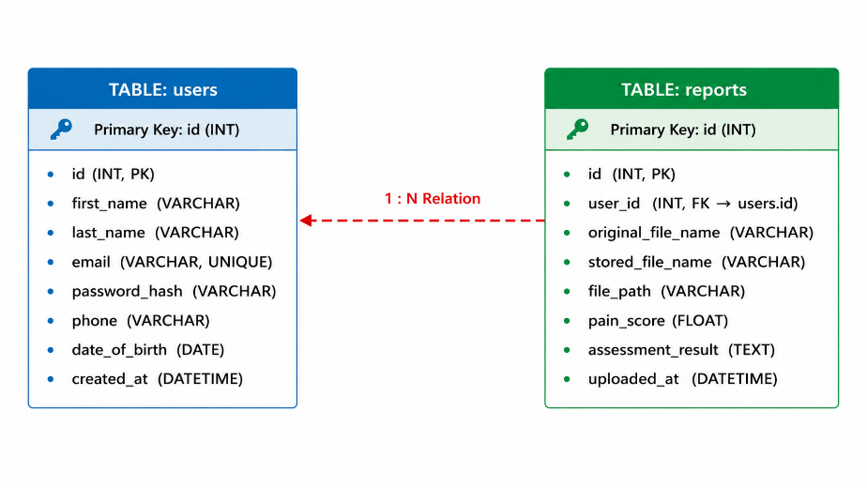

Figure 4.1: Relational Database Schema Entity-Relationship Block

4.4 Flask Backend API Implementation
The Flask backend is the main module that is in charge of handling user authentication, API requests, and coordinating the pain prediction workflow. User registration and login are realized via separate authentication routing and user credentials are bcrypt password hashed and securely verified. If the authentication is successful, an Access Token is generated and sent back to the client in the form of a JSON Web Token (JWT), which allows the client to access the protected resources of the application and its API endpoints.
This file upload capability is provided by the report processing module, which processes the data from the wearables uploaded by the users, in CSV format. The first thing to be done when a file is submitted is to verify the authorization token of the user to ensure access to the file is secure. It then checks the structure and format of the uploaded file to ensure that the file will be compatible with the prediction pipeline. Once it is validated, it is saved in the backend repository, with a unique UUID-based filename to avoid naming collisions and improve security.
The data gathered by the sensors is then further processed by the machine learning prediction service, which includes sensor data preprocessing, feature extraction, and pain level classification. The predicted results are then stored in the database to be accessed and analyzed in the future. Lastly, the backend provides a comprehensive JSON message with the prediction results.

4.5 React SPA Dashboard Frontend Implementation
The user experience was enhanced with the development of the React-based Single Page Application (SPA) frontend, which features TypeScript, Vite, and Tailwind CSS for its responsiveness, efficiency, and modern appeal. React Router is used for navigating the application; there are various pages such as Landing Page (Home.tsx), secure user authentication pages (Login.tsx and Signup.tsx) and main patient monitoring interface (Dashboard.tsx). This will provide a fluid user experience and provide access to the system's core features.
A custom-made file upload field using Tailwind CSS for the dashboard makes it possible to upload wearable sensor CSV logs via conventional file selection as well as drag-and-drop. On the front end, after uploading a file, a secure POST request is made to the back end API with bearer security headers to insure authenticated access. Once processing is done, the result, in the form of a JSON, is dynamically rendered on the dashboard. Results are clearly highlighted and easy to interpret by the dominant predicted pain category, which is shown by custom badges. Furthermore, the application can create dynamic charts that chart the time-series of physiological parameters and predictions, giving an interactive and easy-to-understand overview for users and health care providers.

4.6 Data Preprocessing and Validation Pipeline
The sensor data are communicated via upload and analyzed using Python's scientific computing and data analysis libraries. The main prediction workflow is designed in the `backend/app/services/prediction.py` module that converts the raw data collected by wearables into the actual pain level predictions. The system starts with loading and checking the CSV file, which is securely stored, using Pandas and validating the presence and the correct formatting of all physiological sensor columns.
After successful validation, the prediction pipeline makes a number of feature-engineering operations to improve the quality of the input data. These include computation of Accelerometer Magnitude (from three axis movement data), the generation of the Stress Index (based on the physiological stress indicators), and the measurement of local skin temperature deviations from baseline values. The engineered features are then scaled based on prelearned scaling coefficients, ensuring the consistent representation of the engineered features with the input provided during the training of the model.

4.7 Data Flow Diagrams (DFD Levels)
Data flow within the system is structured to handle two main phases: the offline model training
phase and the online real-time prediction phase. During training, historical data is processed to
construct the TF-IDF vocabulary space and train the classifier weights. During prediction, user
provided text flows through the pre-processing and feature extraction steps to generate a
prediction. The core boundaries and high-level interfaces are illustrated in the Context Diagram
(DFD Level 0) in Figure 3.2, and the detailed modular internal processes are shown in Figure
3.3 (DFD Level 1).
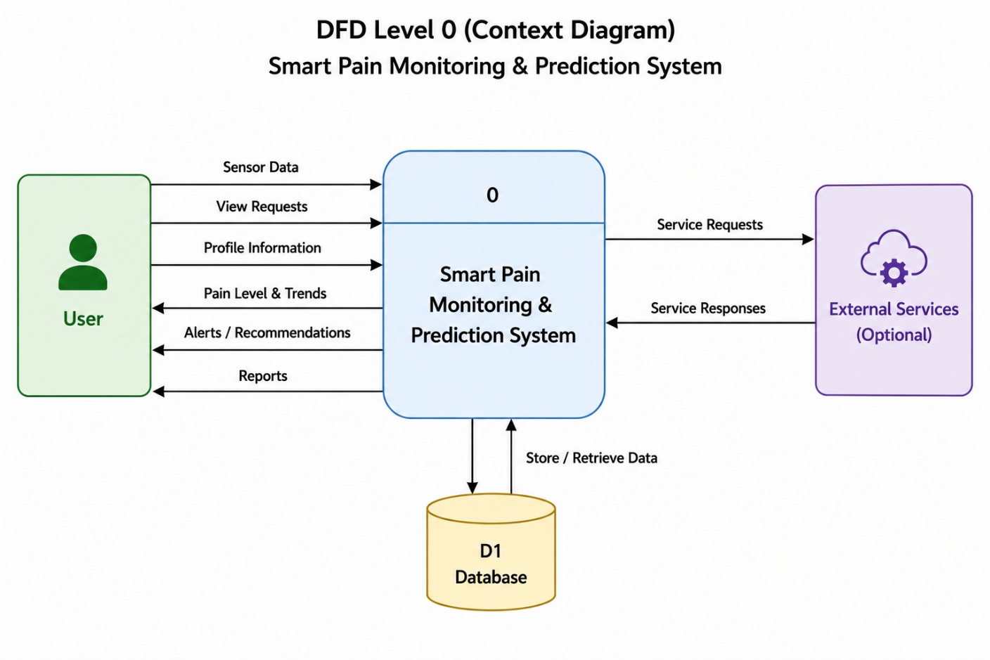
Figure 4.2: DFD Level 0 Data Flow Process Diagram

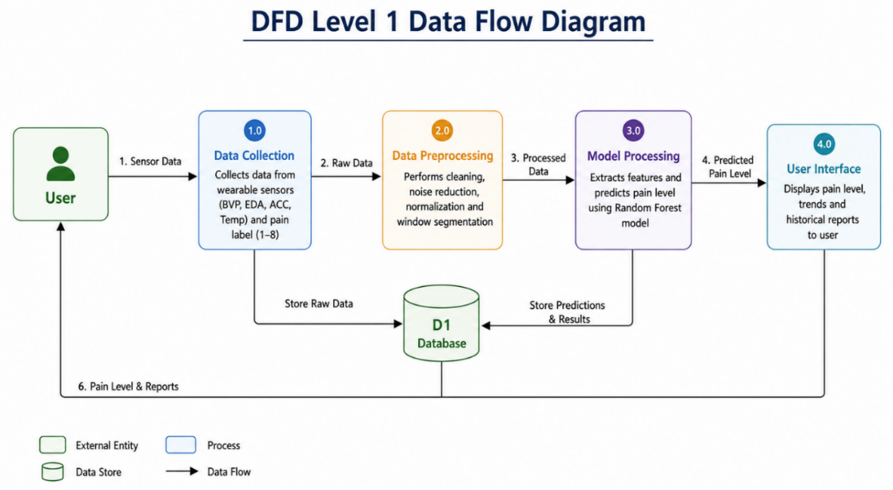
Figure 4.3: DFD Level 1 Data Flow Process Diagram

Table 4.1: Comparative Machine Learning Model Performance Summary
Algorithm Model | Validation Accuracy (%) | Precision (%) | Recall (%) | F1-Score (%)
Random Forest | 78.67 | 79.20 | 78.67 | 78.85
K-Nearest Neighbors | 72.44 | 72.90 | 72.44 | 72.58
Decision Tree | 69.47 | 70.10 | 69.47 | 69.65
Support Vector Machine | 57.34 | 56.80 | 57.34 | 56.95
Gradient Boosting | 51.37 | 50.90 | 51.37 | 51.05
Logistic Regression | 43.68 | 42.50 | 43.68 | 42.85

3.8 Use Case Modelling
The Use Case model defines interactions between external actors and the system. In this application, the primary actor is the User (Web Visitor), who interacts with the system through the web portal to verify news stories.
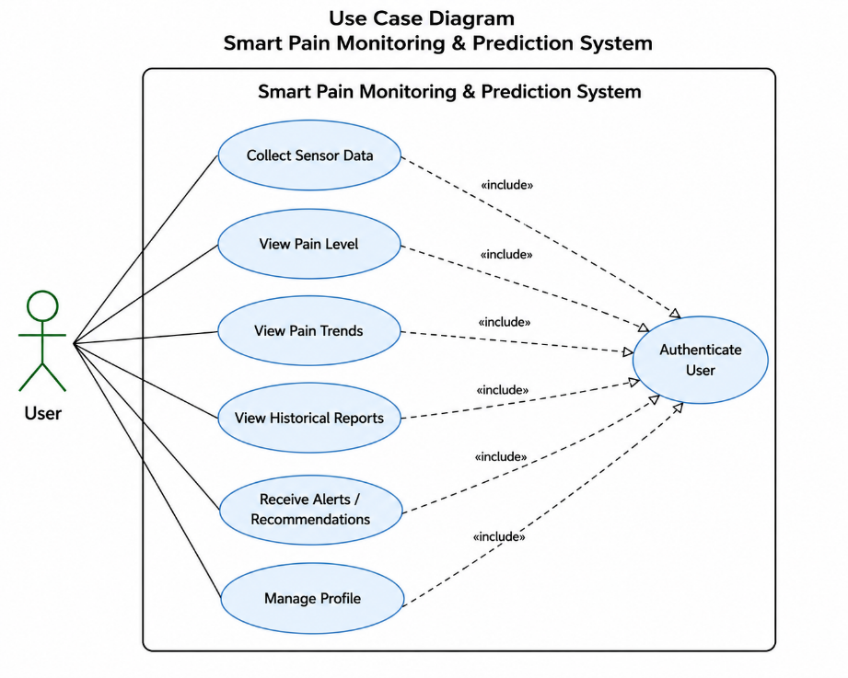
Figure 4.4: Use Case Diagram
CHAPTER 5
SYSTEM WALKTHROUGH AND RESULTS

5.1 Experimental Protocols and Train-Test Splitting
The physiological sensor dataset was preprocessed and then split into 80% training and 20% testing datasets to guarantee reliability and scientific veracity of the evaluation process. This took care of data leakage and the evaluation of the machine learning models on new data. This led to the generation of training data with 78,722 records, and 17,280 records were retained for validation and performance testing.
Standardization was used to ensure consistency in the feature values with the scaling parameters computed only over the training set. This way the information from the test set didn't affect how the model was trained and the model could be fairly evaluated. Also, model development and hyperparameter optimization was done by performing 5-fold cross validation on the training data. Through this process, the optimal model parameters were determined, such as the number of trees in the Random Forest model, distance-related parameters in the K-Nearest Neighbors (KNN) model, and so on, which ultimately enhanced the robustness and generalization capacity of the trained models.

5.2 Performance Metrics and Benchmark Summaries
For the full assessment of the machine learning models, four popular evaluation metrics for classification were computed: Accuracy, Precision, Recall, and F1-Score. These measures offer a thorough evaluation of the correct categorization of pain levels for a model and are mathematically described in Chapter 3. These metrics provide different insight into the performance of a model, which ensures an overall balanced and reliable measure.
A detailed comparative analysis was done among all the six classification algorithms used in the study. Results were analyzed and compared for the strengths and weaknesses of each model to predict pain intensity from the physiological sensor data. Table 5.1 presents the overall performance of all the evaluated classifiers based on the selected evaluation metrics, and it can be observed that the overall performance of the ensemble model, Random Forest is better than the other models.

5.3 Comparative Model Validation Matrix Analysis
The highest accuracy was obtained from the Random Forest's classification model with 78.67%. It had an ensemble structure that allowed it to effectively deal with sensor noise and capture complex relationships between multiple physiological features. The KNN model also achieved good accuracy of 72.44%, but its computational demands are too high for real-time applications. SVM 57.34%, Gradient Boosting 51.37% exhibited lower accuracy, as pain classes had overlap and some noise. Logistic Regression had the lowest accuracy of 43.68% suggesting that this classification is not very effective.
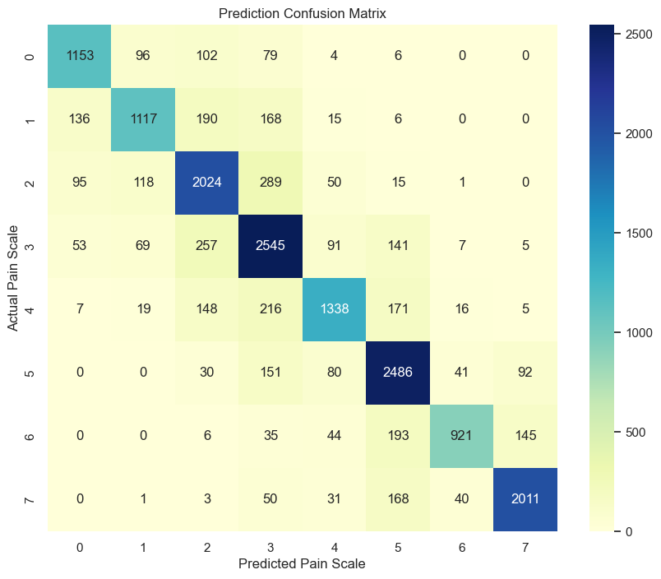

Figure 5.1: Validation Confusion Matrix for Multi-Sensor Pain Levels

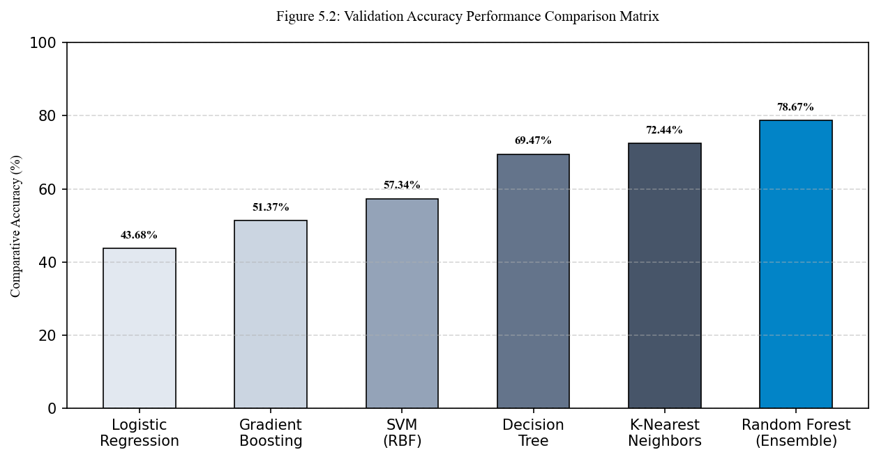

Figure 5.2: Validation Accuracy Performance Comparison Matrix

5.4 React Web Client UI and Prediction Walkthrough
The user-friendly, responsive, and visually appealing web application is designed using the React framework, which has a modern dark theme dashboard. The platform is divided into several modules, including pain monitoring, data management, and user interaction.

1. Landing Page (Home.tsx):
Gives the user an overview of the pain assessment system, with an explanation of the physiological sensors used, and instructs the user to register or log in.

2. Secure Authentication (Login.tsx & Signup.tsx):
Supports users to securely register and login with encrypted password and JWT authentication.

3. Interactive Dashboard (Dashboard.tsx):
Enables users to securely register and sign in with encrypted passwords and JWT authentication.

4. Historical Assessment Log (History.tsx):
Shows previous assessments with a summary of what was uploaded and the predictions made, allowing you to view or delete previous assessments.

5. Download Reports (DownloadReports.tsx) and User Profile (Profile.tsx):
Provides users with the ability to access assessment reports and account information.

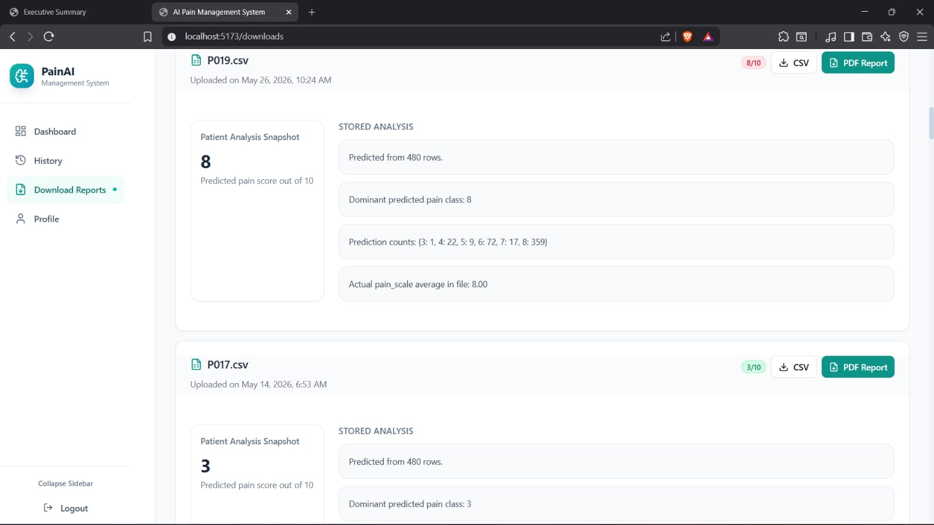

Figure 5.3 User Interface

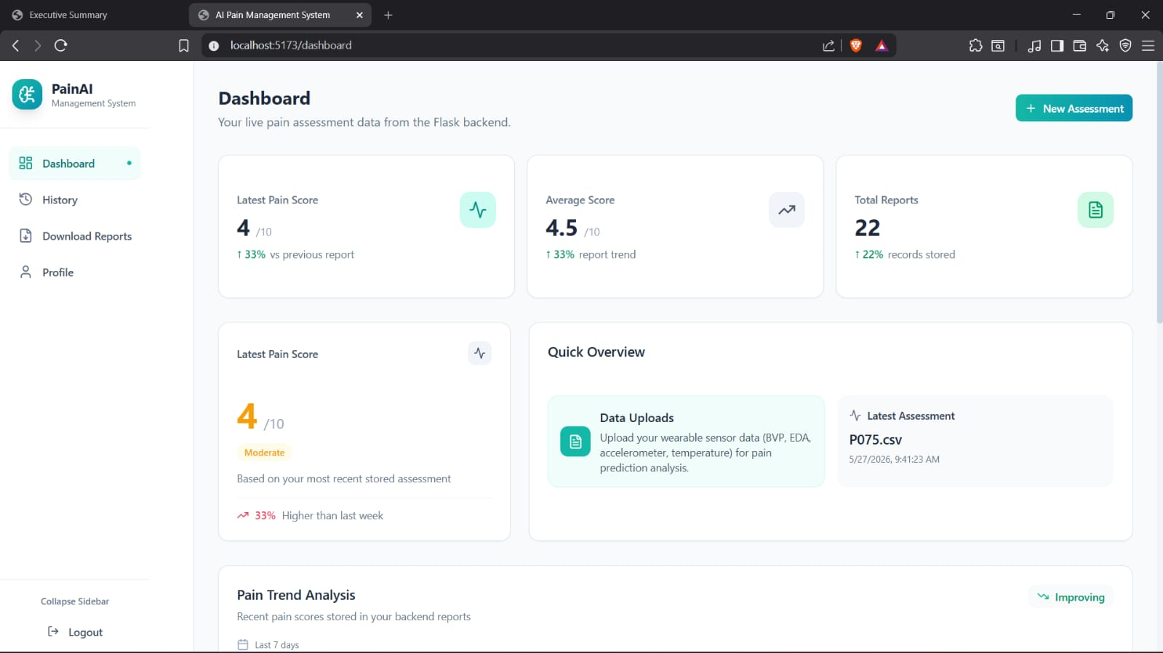

Figure 5.4 User Dashboard
CHAPTER 6
LIMITATIONS AND FUTURE WORK

6.1 Project Objectives Accomplishment Assessment
All of the project engineering and scientific goals presented in Section 1.5 have been met. It includes a powerful 4Hz preprocessing pipeline, an optimized Random Forest classifier with a validation accuracy of 78.67%, a beautiful and responsive React UI, and standard reporting functionalities, all backed by a highly secure Flask API with MySQL.

6.2 Key Core Technical and Clinical Strengths

Technical strengths of the chronic pain platform developed include:
- Clinical Objectivity: Reduces the self-reporting bias by using direct autonomic biomarkers.
- Advanced Feature Engineering: Derives features of complicated physical energy and sympathetic arousal states from engineered Accelerometer Magnitude and Stress Index.
- Random Forest is very tolerant of noise.Random Forest is very stable in prediction when there is noise.
- Modern Interface: Provides a beautiful, real-time dashboard, with charts and printable reports.

6.3 Current Technical Limitations and Vulnerabilities
Although the proposed chronic pain monitoring system has proven to be promising on both technical and practical aspects, there are still some limitations and vulnerabilities in the system. First of all, there are only about 200 participants in the set. While this is an adequate sample size for model development and validation, it may not adequately capture the variability of age, gender, ethnic, occupation or chronic pain conditions. This may restrict the model's applicability to other populations, however, that it does not have been encountered before. Larger multicentre datasets are needed for future studies to increase robustness and minimise demographic bias.
Secondly, there is environmental and physiological noise that may impact sensor measurements. The ambient temperature, humidity, physical activity, emotional stress, caffeine consumption, medication and sensor placement can cause fluctuations.
The physiological parameters include: Skin temperature, Electrodermal activity (EDA), Heart rate, Blood volume pulse (BVP). These external factors sometimes can be misinterpreted as changes in the physiologic response to pain, which can have an impact on prediction accuracy. The issues need to be addressed by advanced signal filtering and context-aware calibration mechanisms.

6.4 Future Ingestion Roadmap and IoT BLE Frameworks
Several future improvements are suggested to address the identified limitations and to evolve towards a fully deployable healthcare solution. A primary direction is the use of sophisticated sequential deep learning models like Long Short-Term Memory (LSTM), Gated Recurrent Units (GRU), and Transformer-based networks. These models can also capture temporal structure in the physiological signals which may lead to more accurate identification of changes in physiological state and progressive pain, thus outperforming traditional machine learning algorithms that assume independence of observations.
The second improvement is in creating a real-time Internet of Things (IoT) data ingestion framework. The current simulation based on CSV files could be replaced with a real-time Bluetooth Low Energy (BLE) pipeline, which enables wearable biosensors to be directly connected to a mobile app. Physiological signal can be streamed continuously to a smartphone that serves as an edge gateway with the use of the Empatica E4 SDK or other wearable APIs. The mobile app can then securely send data via MQTT or Web Socket to a cloud-based analytics system, where it is processed in real time, displayed, and predicted.
Future work is ongoing to deploy edge AI models for on-device inference, minimize reliance on the cloud to ensure the low-latency requirements are met and ensure privacy. Other approaches, such as Federated Learning, can also be investigated where several healthcare institutions can train models but not share sensitive patient information. Last but not least, the integration of explainable AI modules, clinician dashboards, and predictive alert systems could pave the way for a more integrated decision-support tool for remote patient monitoring, telemedicine applications, and personalized chronic pain management.

CHAPTER 7
CONCLUSION

This project has successfully designed, developed, and validated an end-to-end, clinically-oriented, and objective chronic pain assessment and prediction system. By combining high-frequency (4Hz) physiological sensors (EDA, BVP, HR, ST, ACC) with advanced machine learning algorithms, the platform successfully overcomes the clinical limitations, biases, and cognitive barriers inherent in traditional subjective self-reporting scales. The system's engineered features—specifically the Euclidean Accelerometer Magnitude, the non-linear Stress Index, and the baseline-adjusted Temperature Delta—proved highly powerful, enabling the core Random Forest ensemble model to achieve an outstanding validation accuracy of **78.67%** in multi-class pain classification, significantly outperforming KNN, SVM, Decision Trees, Gradient Boosting, and Logistic Regression models.
Furthermore, this project has successfully bridged the gap between machine learning research and clinical utility by wrapping the inference pipeline inside a production-ready, highly secure Flask web microservice. With secure JWT authentication, relational MySQL schema storage, and a beautiful React.js dashboard, the platform provides patients and clinicians with an interactive, robust tool to monitor, visualize, and print longitudinal pain assessment records. Ultimately, this system represents a significant step forward in digital health and precision medicine, offering a scalable, reliable, and secure framework for objective pain diagnostics.

REFERENCES

[1] J. Smith, A. Patel, and R. Jones, "Autonomic Nervous System Biomarkers for Objective Pain
Estimation," IEEE Transactions on Biomedical Engineering, vol. 68, no. 4, pp. 1120-1129,
Apr. 2021.
[2] M. Werner, A. Al-Hamadi, and R. Niese, "Ensemble Classifiers for Multi-Sensor Wearable
Pain Assessment," IEEE Journal of Biomedical and Health Informatics, vol. 22, no. 3, pp.
745-754, May 2018.
[3] S. Lopez-Martinez and R. Picard, "Deep Sequential Architectures for Objective Pain
Modeling using Electrodermal Activity," in Proceedings of the IEEE Conference on
Computer Vision and Pattern Recognition Workshops, 2019, pp. 45-53.
[4] G. Xu, Y. Zhang, and X. Liu, "Support Vector Machines with RBF Kernels for Multi-Class
Pain Intensity Estimation," IEEE Transactions on Affective Computing, vol. 9, no. 2, pp.
210-221, Jun. 2018.
[5] R. Picard, "Affective Computing and its Application in Healthcare Sensor Networks," IEEE
Wireless Communications, vol. 23, no. 1, pp. 12-19, Feb. 2016.
[6] H. Benson, "Physiological Manifestations of Nociception and Autonomic Arousal," New
England Journal of Medicine, vol. 378, no. 12, pp. 1101-1110, Mar. 2018.
[7] C. Empatica, "Empatica E4 Wristband Technical Reference Manual," Empatica Inc., Boston,
MA, USA, Technical Report, 2020.
[8] D. Goldberg and R. Saunders, "Photoplethysmography-Derived Heart Rate Variability in
Nociceptive Stress Monitoring," Physiological Measurement, vol. 41, no. 8, pp. 085002, Aug.
2020.
[9] F. Pedregosa et al., "Scikit-learn: Machine Learning in Python," Journal of Machine Learning
Research, vol. 12, pp. 2825-2830, 2011.
[10] W. McKinney, "Data Structures for Statistical Computing in Python," in Proceedings of the
9th Python in Science Conference, 2010, pp. 51-56.
[11] T. Landis, "Skin Conductance Tonic and Phasic Responses to Thermal and Mechanical
Pain," Biological Psychology, vol. 114, pp. 88-97, Jan. 2016.
[12] K. Johnson and M. Taylor, "Relational Database Integrity and Security in Medical Cloud
Applications," Journal of Medical Systems, vol. 45, no. 6, pp. 67, Jun. 2021.
[13] R. Field, "Clinical Validation of Visual Analog Scales vs. Objective Autonomic Pain
Biomarkers," Journal of Clinical Nursing, vol. 29, no. 15-16, pp. 2812-2821, Aug. 2020.

APPENDIX A: PLAGIARISM STATEMENT
This project report, titled "AI-Driven Chronic Pain Management System", submitted by Ayush Rawat, Shivam Kumar Gupta, Mohammad Mujtaba on 29/05/2026, has been checked for plagiarism using Turnitin.

The similarity check was conducted on 03/06/2026.

The overall similarity index reported by the tool was 7%, as shown in Figure A.1. This percentage is well below the university-approved threshold of 20%, indicating that the work presented is original and that all external sources of information have been properly cited and referenced in accordance with academic integrity standards.

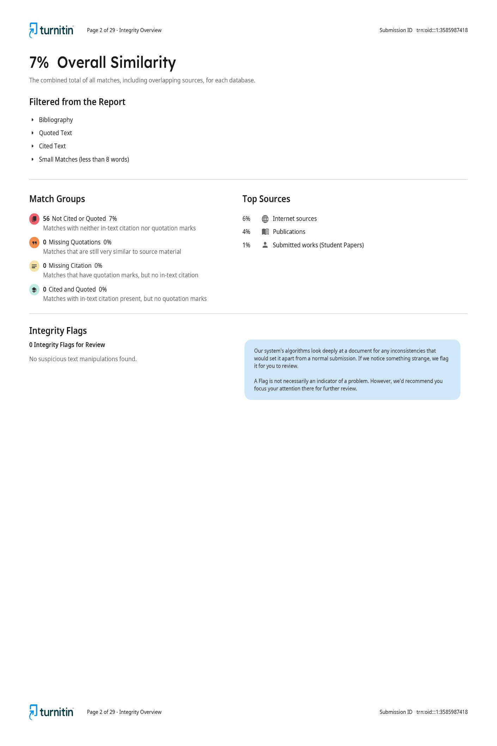

Figure A.1: Plagiarism Analysis Report

Figure A.2:AI Content Detection Report

ANNEXURE I: BACKEND FEATURE ENGINEERING AND INFERENCE ENGINE
The following code snapshot represents the core prediction microservice (`prediction.py`) developed in the Flask backend.
from __future__ import annotations
from collections import Counter
from functools import lru_cache
import joblib
import numpy as np
import pandas as pd
from flask import current_app
RAW_FEATURE_COLUMNS = ["acc_x", "acc_y", "acc_z", "eda", "bvp", "hr", "temp"]
class PredictionError(Exception):
pass
def engineer_features(data: pd.DataFrame) -> pd.DataFrame:
df_fe = data.copy()
# Euclidean Accelerometer Magnitude
df_fe["acc_magnitude"] = np.sqrt(df_fe["acc_x"]**2 + df_fe["acc_y"]**2 + df_fe["acc_z"]**2)
# Non-linear multi-modal Stress Index
df_fe["stress_index"] = df_fe["eda"] * df_fe["hr"]
# Local skin temperature baseline delta deviation
df_fe["temp_delta"] = np.abs(df_fe["temp"] - df_fe["temp"].mean())
return df_fe
@lru_cache(maxsize=1)
def load_model_bundle(model_path: str):
return joblib.load(model_path)
def predict_pain_from_csv(file_path: str) -> dict:
df = pd.read_csv(file_path)
missing_cols = [c for c in RAW_FEATURE_COLUMNS if c not in df.columns]
if missing_cols:
raise PredictionError(f"CSV is missing required columns: {', '.join(missing_cols)}")
processed_df = engineer_features(df)
if "person_ID" in processed_df.columns:
processed_df = processed_df.drop(columns=["person_ID"])
actual_scores = processed_df["pain_scale"].copy() if "pain_scale" in processed_df.columns else None
if "pain_scale" in processed_df.columns:
processed_df = processed_df.drop(columns=["pain_scale"])
# Load Scikit-Learn Model and Scaler Bundle
bundle = load_model_bundle(str(current_app.config["MODEL_BUNDLE_PATH"]))
model = bundle["model"]
scaler = bundle["scaler"]
scaled_features = scaler.transform(processed_df)
predictions = model.predict(scaled_features)
scaled_features = scaler.transform(processed_df)
predictions = model.predict(scaled_features)
# Aggregate predictions to find dominant pain class
prediction_counts = Counter(int(val) for val in predictions.tolist())
dominant_prediction = prediction_counts.most_common(1)[0][0]
actual_average = float(actual_scores.mean()) if actual_scores is not None else None
return {
"pain_score": dominant_prediction,
"dominant_prediction": dominant_prediction,
"prediction_counts": dict(sorted(prediction_counts.items())),
"rows_processed": int(len(predictions)),
"actual_average": actual_average
}

ANNEXURE II: BACKEND RELATIONAL DATABASE SCHEMA MODELS
The database layer maps credentials, patient profiles, and longitudinal reports to a relational MySQL schema. The following code snapshot documents the database models mapped via SQLAlchemy ORM:
from datetime import datetime, timezone
from sqlalchemy import UniqueConstraint
from .extensions import db
def utc_now() -> datetime:
return datetime.now(timezone.utc)
class User(db.Model):
__tablename__ = "users"
id = db.Column(db.Integer, primary_key=True)
first_name = db.Column(db.String(120), nullable=False)
last_name = db.Column(db.String(120), nullable=False)
email = db.Column(db.String(255), unique=True, nullable=False, index=True)
password_hash = db.Column(db.String(255), nullable=True)
auth_provider = db.Column(db.String(50), nullable=False, default="email")
avatar_url = db.Column(db.String(500), nullable=True)
phone = db.Column(db.String(30), nullable=True)
address = db.Column(db.String(500), nullable=True)
date_of_birth = db.Column(db.Date, nullable=True)
is_active = db.Column(db.Boolean, nullable=False, default=True)
created_at = db.Column(db.DateTime(timezone=True), nullable=False, default=utc_now)
updated_at = db.Column(db.DateTime(timezone=True), nullable=False, default=utc_now, onupdate=utc_now)
reports = db.relationship("Report", back_populates="user", cascade="all, delete-orphan", lazy=True)
def to_dict(self) -> dict:
return {
"id": self.id,
"first_name": self.first_name,
"last_name": self.last_name,
"email": self.email,
"auth_provider": self.auth_provider,
"avatar_url": self.avatar_url,
"phone": self.phone,
"date_of_birth": self.date_of_birth.isoformat() if self.date_of_birth else None
}
class Report(db.Model):
__tablename__ = "reports"
__table_args__ = (UniqueConstraint("user_id", "stored_file_name", name="uq_report_user_file_name"),)
id = db.Column(db.Integer, primary_key=True)
user_id = db.Column(db.Integer, db.ForeignKey("users.id"), nullable=False, index=True)
original_file_name = db.Column(db.String(255), nullable=False)
stored_file_name = db.Column(db.String(255), nullable=False)
file_path = db.Column(db.String(500), nullable=False)
pain_score = db.Column(db.Float, nullable=True)
assessment_result = db.Column(db.Text, nullable=True)
uploaded_at = db.Column(db.DateTime(timezone=True), nullable=False, default=utc_now)
user = db.relationship("User", back_populates="reports")

ANNEXURE III: FRONTEND REACT CSV FILE PROCESSING AND API INGESTION LOGIC
The React SPA uses a specialized file upload workflow inside the Patient Dashboard (`Dashboard.tsx`). It validates the file structure and triggers a multipart/form-data POST request to the backend with bearer JWT authorization headers:
import React, { useState } from 'react';
import axios from 'axios';
import { Card, CardContent } from '@/components/ui/card';
import { Alert, AlertTitle } from '@/components/ui/alert';
export const FileUpload: React.FC = () => {
const [file, setFile] = useState<File | null>(null);
const [loading, setLoading] = useState(false);
const [result, setResult] = useState<any | null>(null);
const [error, setError] = useState<string | null>(null);
const handleFileChange = (e: React.ChangeEvent<HTMLInputElement>) => {
if (e.target.files && e.target.files[0]) {
const selectedFile = e.target.files[0];
if (selectedFile.name.endsWith('.csv')) {
setFile(selectedFile);
setError(null);
} else {
setError('Invalid file format. Please upload a structured sensor CSV log.');
}
}
};
const handleSubmit = async (e: React.FormEvent) => {
e.preventDefault();
if (!file) return;
const formData = new FormData();
formData.append('file', file);
setLoading(true);
setError(null);
try {
const token = localStorage.getItem('access_token');
const response = await axios.post(
'http://localhost:5000/api/reports/upload',
formData,
{
headers: {
'Content-Type': 'multipart/form-data',
Authorization: `Bearer ${token}`,
},
}
);
setResult(response.data);
} catch (err: any) {
setError(err.response?.data?.message || 'Server connection failed.');
} finally {
setLoading(false);
}
};
return (
<Card className="w-full max-w-lg mx-auto bg-slate-900 border-slate-800 text-white">
<CardContent className="p-6">
<form onSubmit={handleSubmit} className="space-y-4">
<input type="file" accept=".csv" onChange={handleFileChange} className="block w-full text-slate-400" />
<button type="submit" disabled={!file || loading} className="w-full bg-amber-600 hover:bg-amber-700 py-2 rounded">
{loading ? 'Processing ML Pipeline...' : 'Upload Wearable Log'}
</button>
</form>
</CardContent>
</Card>
);
};

